KWAME NKRUMAH UNIVERSITY OF SCIENCE AND TECHNOLOGY

KUMASI, GHANA (MAIN CAMPUS)



COLLEGE OF ENGINEERING

DEPARTMENT OF MATERIALS ENGINEERING

BSC. MATERIALS ENGINEERING

GROUP 4

TOPIC: CERAMIC PROCESSING - EARTHENWARE BOWL

INSTRUCTOR: DR. EMMANUEL KWESI ARTHUR

|  |  |  |
| --- | --- | --- |
| **NAME** | **INDEX NUMBER** | **SIGNATURE** |
| AMPONSAH, Elizabeth Nyantakyi | 1961922 |  |
| AMPONSAH, Princess Anna | 1962022 |  |
| AMEKUDZI, Reeves Edzordzi | 1961722 |  |
| AMOAKO, Edwin | 1961822 |  |

**Abstract**

This report provides a comprehensive overview of traditional ceramics production earthenware bowl processes, focusing on key stages such as raw material preparation, shaping, drying, and firing. The preparation of raw materials involves techniques like crushing and grinding to achieve the desired particle size, followed by shaping methods such as hand molding, potter's wheel, and mechanized processes like jiggering and extrusion. Drying and firing are crucial steps that involve the removal of moisture and sintering to achieve the final ceramic product.

Scientific concepts underlying these processes, including particle size reduction, material plasticity, thermal processing, and phase transformations, are discussed in detail. Understanding these concepts is essential for optimizing traditional ceramics processing techniques and ensuring the production of high-quality ceramic products with desired properties.

Advantages and limitations of traditional ceramics production processes are highlighted, along with improvement methods such as upgrading kiln technology, implementing recycling programs, and fostering collaboration for innovation. By addressing these aspects, traditional ceramics production can enhance efficiency, reduce environmental impact, and maintain consistent product quality.

1. **Introduction to Ceramic Processing**

Ceramics have been an integral part of human civilization for millennia, with a rich history spanning from ancient artistic figurines to modern-day technological advancements.

Ceramics are objects crafted from naturally occurring raw materials such as clay, minerals, and water, shaped into various forms using techniques like handbuilding, wheel-throwing, or mold casting. Upon shaping, these objects undergo firing in kilns at high temperatures, a process that renders them hardened and heat resistant. Ceramics find utility across diverse domains, serving as building materials, functional dinnerware, decorative sculptures, and more.

Traditional ceramics encompass a spectrum of pottery types, each distinguished by its composition and firing process. Among the common examples are earthenware, stoneware, porcelain, and bone china. Earthenware, known for its porous nature, has historical significance dating back to ancient civilizations. Stoneware, with its vitreous surface, reflects a higher firing temperature and enhanced durability. Porcelain, revered for its strength and translucency, has been a hallmark of refinement for centuries. Bone china, a variant of porcelain, boasts exceptional translucency and chip resistance, elevating it to the realm of fine tableware.

* 1. **Historical Background of earthenware**

The earliest examples of earthenware have been found in China and date back to 5000 BCE. These early earthenware objects were typically used for storage and cooking, and they were made using a hand-building technique, where the clay was coiled and then smoothed over to create a vessel.

Earthenware became popular in other parts of the world during the Neolithic period, as people began to settle down and form agricultural communities. In Europe, earthenware was used extensively during the Bronze Age and Iron Age to make pottery and other objects.

During the Middle Ages, earthenware production expanded in Europe, and potters began to use the wheel to create more complex shapes. Earthenware was used to make a variety of objects, including plates, bowls, jugs, and decorative items.

In the 17th and 18th centuries, earthenware became a popular material for the production of decorative arts, particularly in England. Wedgwood, one of the most famous earthenware manufacturers, produced a range of pottery and ceramics that were exported all over the world.

Today, earthenware is still used to make a variety of functional and decorative objects, although it is less commonly used than other types of ceramics such as porcelain or stoneware. In many parts of the world, earthenware is still produced using traditional techniques, and these objects are highly valued for their craftsmanship and beauty.

1. **Tools for ceramic processing**

Some tools for ceramic processing include:

### Potter's needle tool

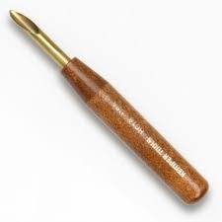

For the trimming of piercing clay in the ceramic, hard pointed wire is fixed at the head of the handle.

### Fork

For scoring and roughing, a dinner fork-shaped tool is used. These are used to join two parts of clay with a sip.

### Fettling knife

For the trim purpose, a tapered shaped knife is utilized.

### Rolling pin with wooden slats

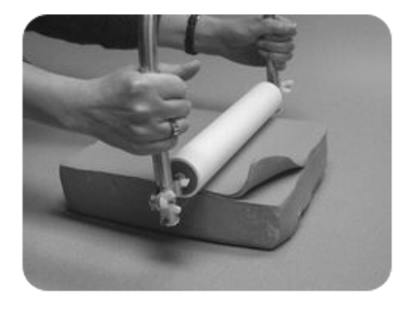

The rolling pin is helpful for the rolling of thick layered clay. The wooden slat is the tool over which the clay is placed, and the pin rolling is performed.

### Loop tools

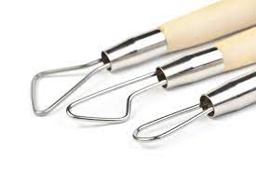They are employed for the trimming of clay.

### Modeling tools

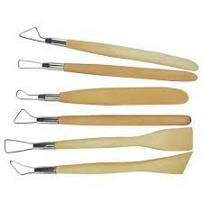

They are utilized for the trimming, texture application, decoration on the outer surface of the clay.

### Rib tools

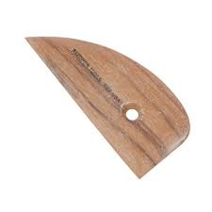

### Rib tools are employed for smoothening of the clay..

### Banding wheel

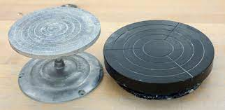

It is used for the decoration or building of pottery. It is a rotational wheel that can be rotated to turn any pottery.

### IMG_256Glaze brush

### This brush is utilized to apply a layer of glaze to the clay. For better protection of the clay, a three-layered glaze is generally applied on the surface of the clay.

### Kiln

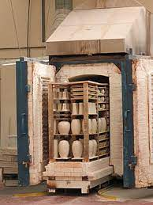

For firing of the clay, a kiln is employed. It is a type of furnace which is made up of refractory materials. They work with the help of electricity, fuel, gas, coal, wood, etc.

1. **Processes in Earthenware bowl Production**

These processes involve the preparation of raw materials, shaping, drying, and firing, each contributing to the distinctive character of the final product.

1. Preparation of the Raw Materials

The preparation of raw materials is a crucial step in traditional ceramics processing, involving the reduction of raw ceramic materials into fine powders suitable for forming. Techniques such as crushing and grinding are employed to achieve the desired particle size.

Crushing: Raw materials undergo compression or impact against rigid surfaces, courtesy of equipment like jaw crushers and hammer mills, breaking large lumps into manageable sizes.

Grinding: Further refinement of the material occurs through grinding, where abrasion and impact in ball mills and roller mills transform coarse particles into fine powders, essential for shaping the earthenware bowl.

2. Shaping

Once the raw materials are prepared, they are formed into plastic paste, typically consisting of ceramic powders and water. Several shaping methods are employed in traditional ceramics production:

Hand Molding: Involves manually shaping the clay paste into desired forms, often using molds or forms to define specific geometries.

Potter's Wheel: Utilizes a rotating table to shape ceramic products of circular cross-section through throwing and shaping techniques.

Mechanized Methods: Including jiggering, plastic pressing, and extrusion, which offer higher production rates and automation compared to hand methods.

Jiggering: A mechanized method used to produce large quantities of identical items such as plates and bowls. It involves pressing a clay slug against a convex mold and shaping it using a heated jigger tool.

3. Drying

Following shaping, the formed clay undergoes a transformative drying phase, crucial for its structural integrity:

Controlled Environment: Within chambers with controlled temperature, the earthenware bowl undergoes gradual moisture removal, safeguarding against deformities like cracking or warping. Heating Methods such as convection and radiation techniques facilitate drying, ensuring the earthenware bowl retains its intended shape and dimensions.

4. Firing (Sintering)

Firing is the final step in traditional ceramics production, where the green ceramic piece is subjected to heat treatment in a kiln to achieve hardness, strength, and densification through sintering. Chemical reactions between components may occur during firing, leading to the formation of bonds and a glassy phase that acts as a binder.

Single Firing and Glazing: Unglazed earthenware bowls experience a single firing, while glazed counterparts undergo a second firing to apply a protective coating. Glazing not only enhances aesthetics but also fortifies against wear and tear.

In essence, the meticulous orchestration of these processes results in the creation of the quintessential earthenware bowl, embodying tradition, craftsmanship, and functionality.

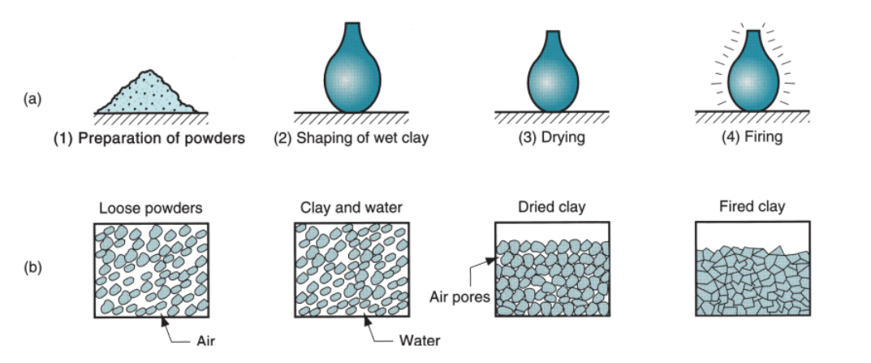

*Process of traditional ceramics*

*Part (a) shows the workpart during the sequence, whereas (b) shows the condition of the powders.retrieved from Groover M.P. (2006). Fundamentals of Modern Manufacturing (3rd ed.). New York NY: John Wiley & Sons. 1040 pp.*

1. **Scientific Concepts Underlying the Processes**

1. Particle Size Reduction:

Particle size reduction is a fundamental aspect of ceramics processing, as it influences the final properties of the ceramic product. The process involves breaking down large raw materials into smaller particles through techniques such as crushing and grinding.

Mechanical Energy: Crushing and grinding operations apply mechanical energy to the raw materials. For example, in crushing, large lumps of raw materials are subjected to compressive forces or impacts against rigid surfaces to break them into smaller sizes.

Brittleness and Compressibility: The effectiveness of particle size reduction techniques depends on the brittleness and compressibility of the ceramic material. Brittle materials tend to fracture under stress, making them more amenable to crushing, while compressibility affects how materials respond to pressure during grinding.

2. Material Plasticity:

Material plasticity refers to the ability of a ceramic paste to deform under applied stress without fracturing. Plasticity is crucial for shaping processes such as molding, throwing, and extrusion.

Water Content: The water content of the ceramic paste plays a significant role in determining its plasticity. A higher water content increases the plasticity of the clay, making it more malleable and easier to shape. However, excessive water content can lead to shrinkage and cracking during drying.

Clay Composition: The composition of the clay, including particle size distribution, mineral content, and organic additives, also influences its plasticity. Clays rich in fine particles and organic matter tend to exhibit higher plasticity.

3. Thermal Processing:

Thermal processing, including drying and firing, involves the application of heat to the ceramic material. These processes influence the removal of moisture, densification, and phase transformations in the ceramic.

Moisture Removal: During drying, heat is applied to remove moisture from the ceramic paste. The rate of moisture removal affects shrinkage and the risk of cracking or warping. Control of temperature and humidity in drying chambers helps mitigate these issues.

Shrinkage: As water is removed from the ceramic during drying and firing, the volume of the material decreases, leading to shrinkage. The extent of shrinkage depends on factors such as clay composition, particle size distribution, and drying conditions.

Densification: Firing involves sintering, a process where ceramic particles bond together and densify under high temperatures. Sintering is facilitated by the mobility of atoms at elevated temperatures, enabling the formation of strong interparticle bonds.

4. Phase Transformations:

Phase transformations occur during firing, leading to changes in the crystal structure and material properties of the ceramic.

Chemical Reactions: At high temperatures, chemical reactions may occur between the components of the ceramic material, leading to the formation of new phases or compounds. These reactions can influence the mechanical, thermal, and electrical properties of the final product.

Glassy Phase Formation: In addition to crystalline phases, firing may also result in the formation of a glassy phase within the ceramic matrix. This glassy phase acts as a binder, enhancing the mechanical strength and durability of the ceramic.

Understanding these scientific concepts is essential for optimizing traditional ceramics processing techniques, ensuring the production of high-quality ceramic products with desired properties.

1. **Advantages**

Advantages of Earthenware Bowl Production Processes:

* Traditional earthenware bowl processes offer a wide range of shaping techniques, from hand molding to mechanized methods like extrusion and jiggering, allowing for the creation of diverse ceramic products.
* These processes enable customization of ceramic products according to specific designs, shapes, and sizes.
* Despite advancements in ceramic manufacturing technologies, traditional processes such as hand molding and plastic pressing remain cost-effective for producing small to medium quantities of ceramic products.
* Traditional earthenware bowl can accommodate a variety of raw materials, including different types of clay, minerals, and additives, providing flexibility in material selection based on desired properties and characteristics.

1. **Limitations**

Limitations of Earthenware Bowl Production Processes:

* Hand molding and certain shaping methods require skilled labor and manual intervention.
* Earthenware Bowl production processes may face challenges in maintaining consistent product quality, especially with handcrafted items where variations in shaping and firing can occur.
* Traditional firing techniques, particularly in kiln operations, may consume significant amounts of energy and release pollutants into the atmosphere.
* The preparation of raw materials and shaping processes may generate waste materials such as excess clay slurry or trimmings, leading to inefficiencies in material usage and disposal.

1. **Improvement Methods**

Improvements for Earthenware Bowl Production Processes:

* Upgrade kiln technology to improve energy efficiency and reduce environmental impact.
* Implement recycling programs for clay slurry, trimmings, and other waste streams to minimize environmental impact and reduce disposal costs.
* Implement quality assurance systems to ensure consistent product quality and meet customer specifications.
* Foster collaboration with industry partners, research institutions, and technology providers to drive innovation and continuous improvement in traditional ceramics production processes.
* Optimizing ceramic powder preparation involves controlling factors like particle size, shape, distribution, purity, and composition using techniques such as milling, spray drying, and chemical vapor deposition, along with additives to enhance flowability and densification.
* Selecting suitable forming methods like pressing, extrusion, or 3D printing, and optimizing parameters such as pressure, temperature, and mold design ensures the production of uniform and defect-free green bodies tailored to the specific ceramic type and application.
* Utilizing various characterization techniques such as optical microscopy, X-ray diffraction, and hardness testing, and optimizing sample preparation and testing conditions, ensures accurate evaluation of ceramic properties like density, mechanical strength, and thermal behavior.

1. **Conclusion**

In conclusion, a variety of shaping methods and material selections are provided by conventional ceramics production processes, enabling the development of customised ceramic goods. Even though these procedures have drawbacks like the need for physical labour and energy consumption, they can be made more efficient and less harmful to the environment by introducing recycling initiatives and modernising kiln technology.

Traditional ceramics production can meet customer specifications and guarantee consistent product quality by optimising ceramic powder preparation, choosing appropriate forming techniques, and putting quality assurance systems in place. To promote innovation, cooperation with research institutes and industry partners is essential.

Overall, traditional ceramics production processes remain relevant in today's manufacturing landscape, offering cost-effective solutions for producing ceramic products with unique designs and properties. With ongoing advancements and improvements, traditional ceramics production can continue to thrive and meet the evolving needs of various industries.

**References**

* Bralla, J. G. (Ed.). (1999). Design for Manufacturability Handbook (2nd ed.). McGraw-Hill: New York.
* Hlavac, J. (1983). The Technology of Glass and Ceramics. Elsevier Scientific Publishing: New York.
* Kingery, W. D., Bowen, H. K., & Uhlmann, D. R. (1995). Introduction to Ceramics (2nd ed.). John Wiley & Sons: New York.
* Rahaman, M. N. (2007). Ceramic Processing. CRC Taylor & Francis: Boca Raton, Florida.
* Richerson, D. W. (2006). Modern Ceramic Engineering: Properties, Processing, and Use in Design (3rd ed.). CRC Taylor & Francis: Boca Raton, Florida.
* Schwarzkopf, P., & Kieffer, R. (1960). Cemented Carbides. Macmillan: New York.
* Singer, F., & Singer, S. S. (1963). Industrial Ceramics. Chemical Publishing Company: New York.
* Somiya, S. (Ed.). (1989). Advanced Technical Ceramics. Academic Press: San Diego, California.
* Groover, M. P. (2006). Fundamentals of Modern Manufacturing (3rd ed.). John Wiley & Sons: New York, NY. ISBN 0-471-74485-9.
* Ghosh, A., & Mallik, A. K. Manufacturing Science.
* How can you optimize ceramics processing? (n.d.). Retrieved from https://www.linkedin.com/advice/3/how-can-you-optimize-ceramics-processing-90yze